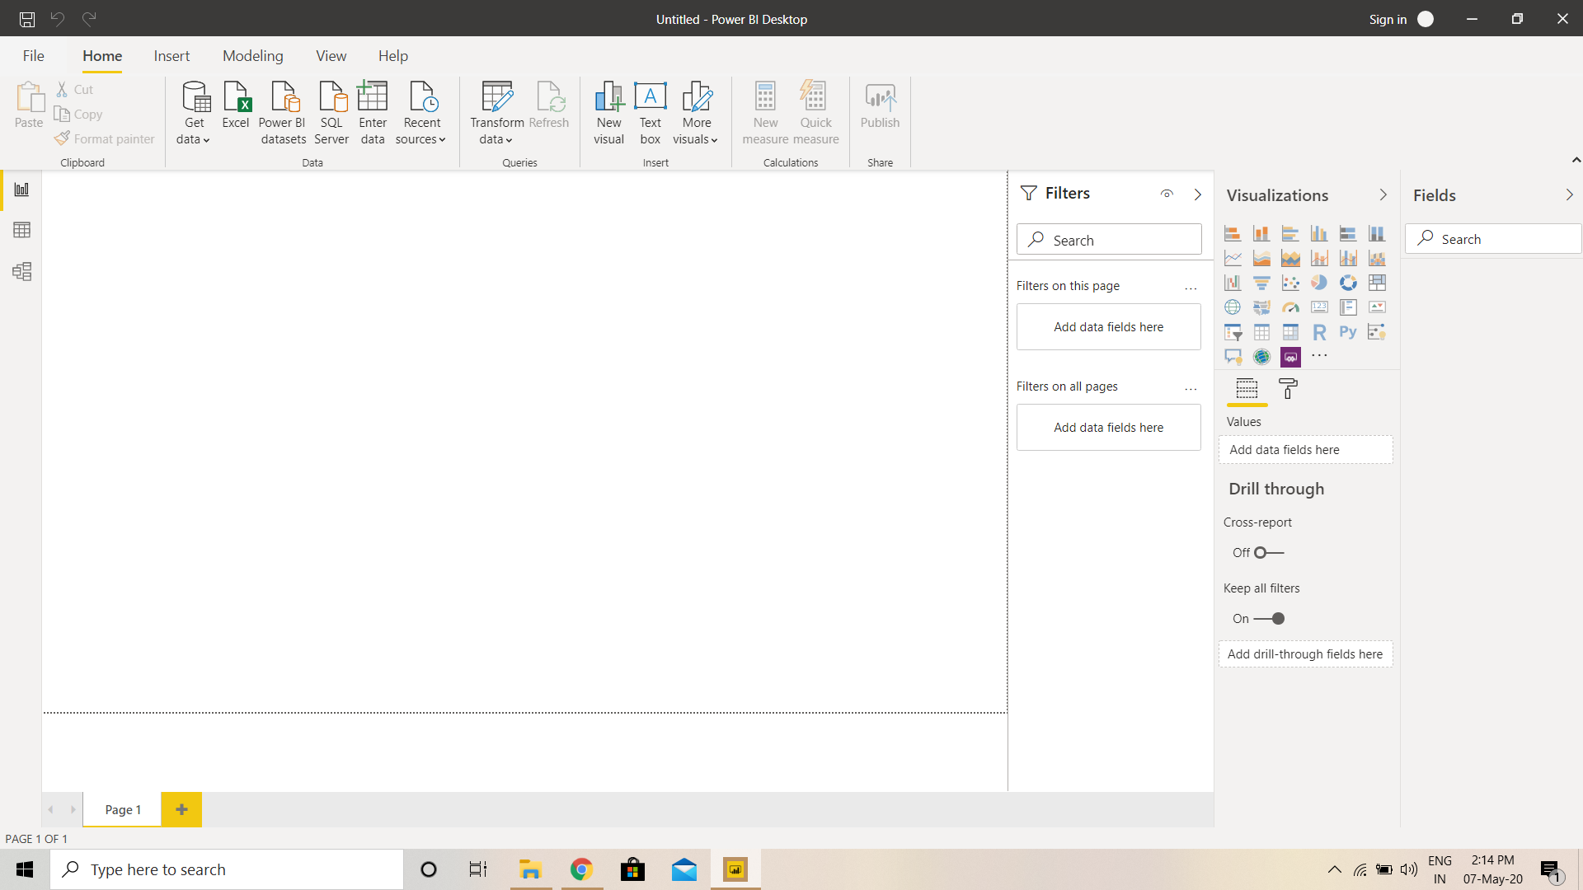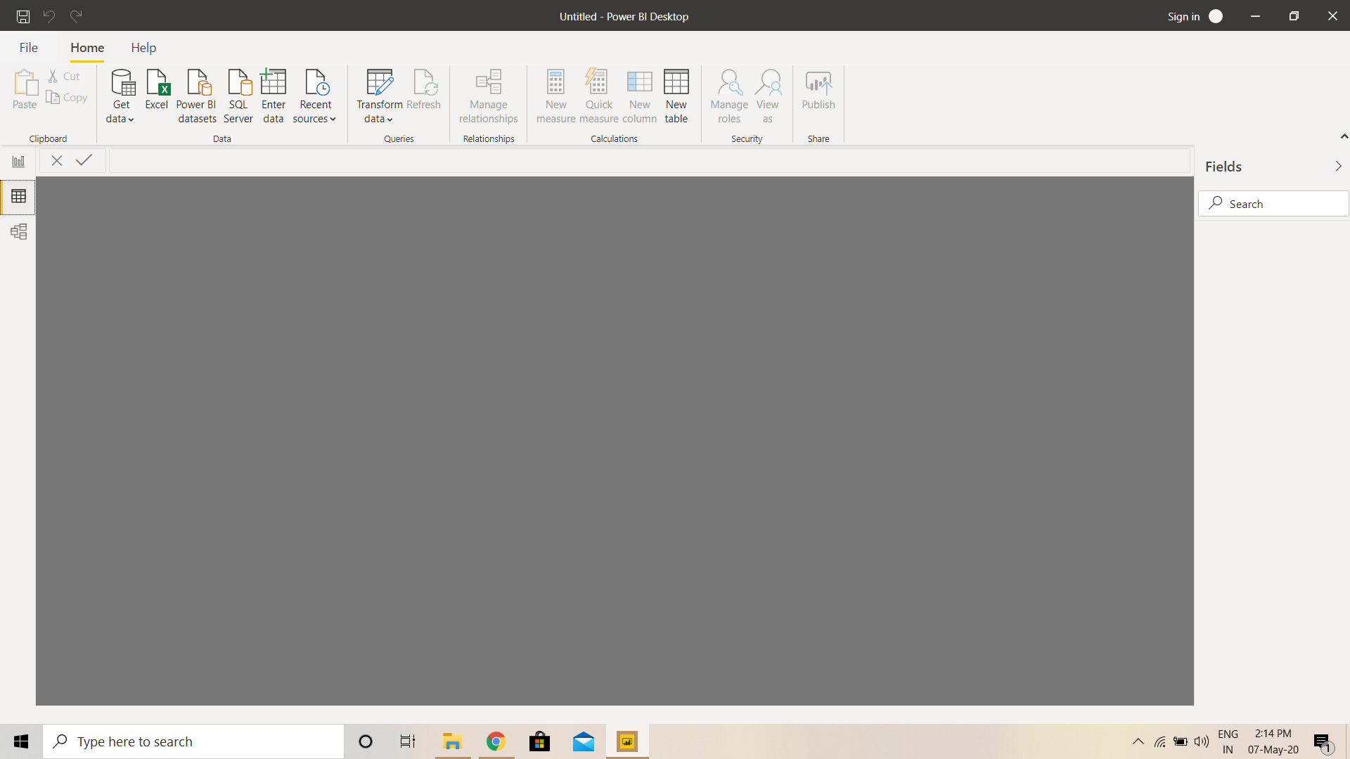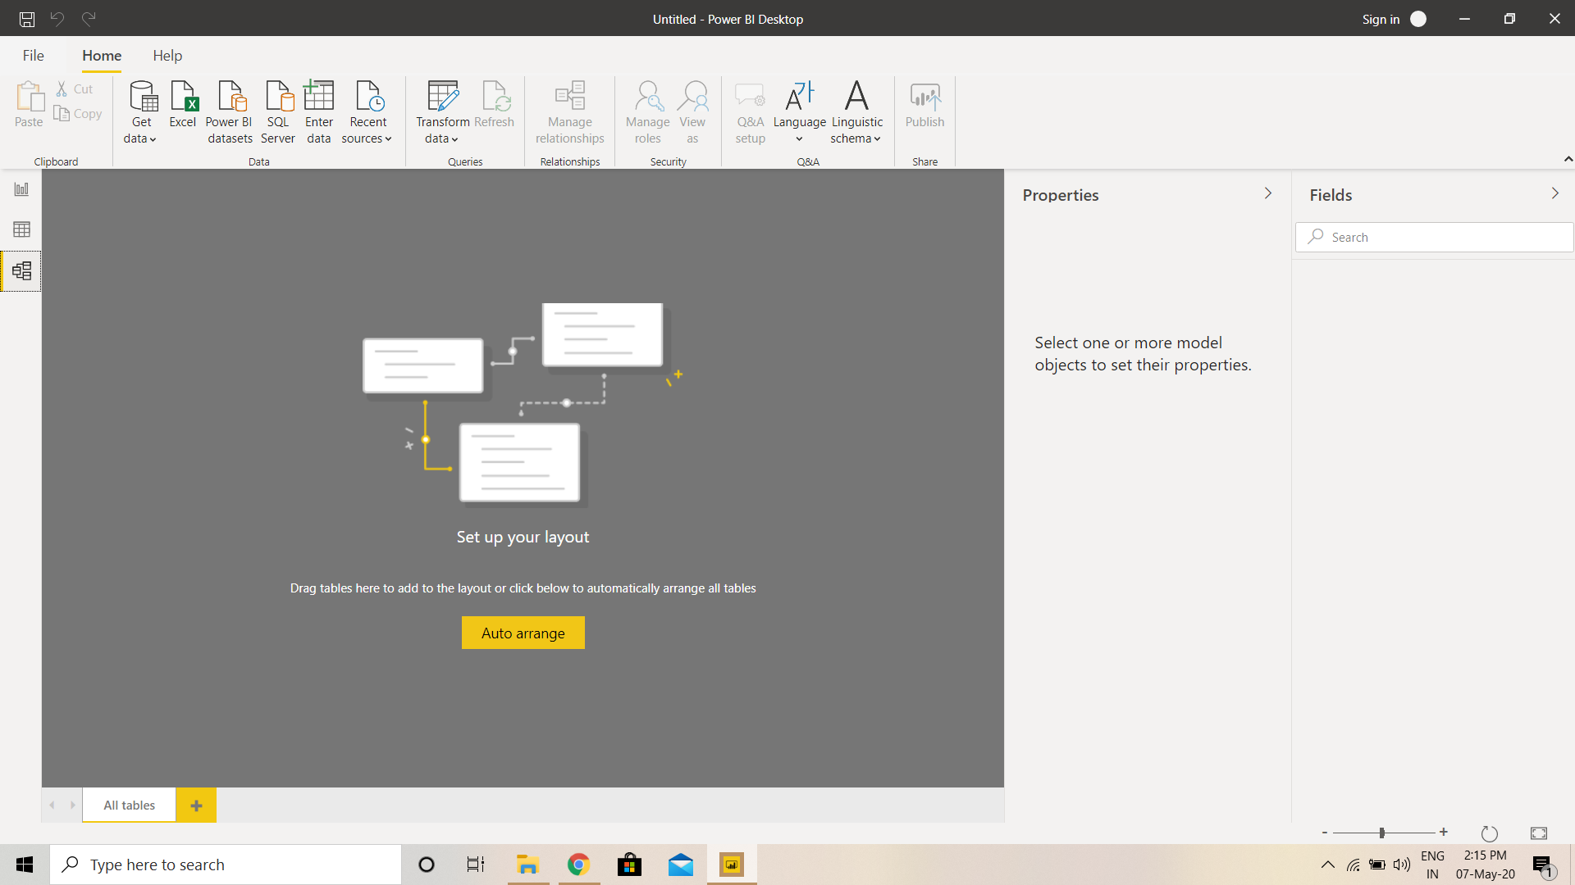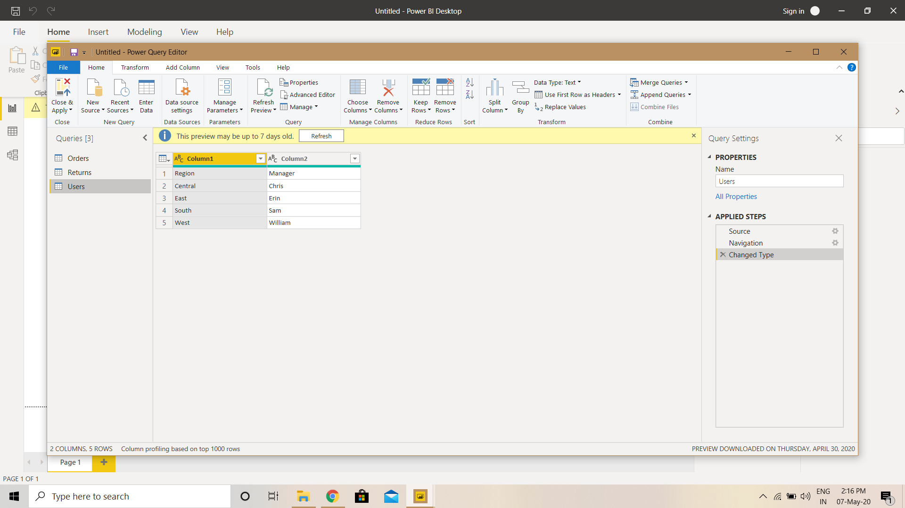

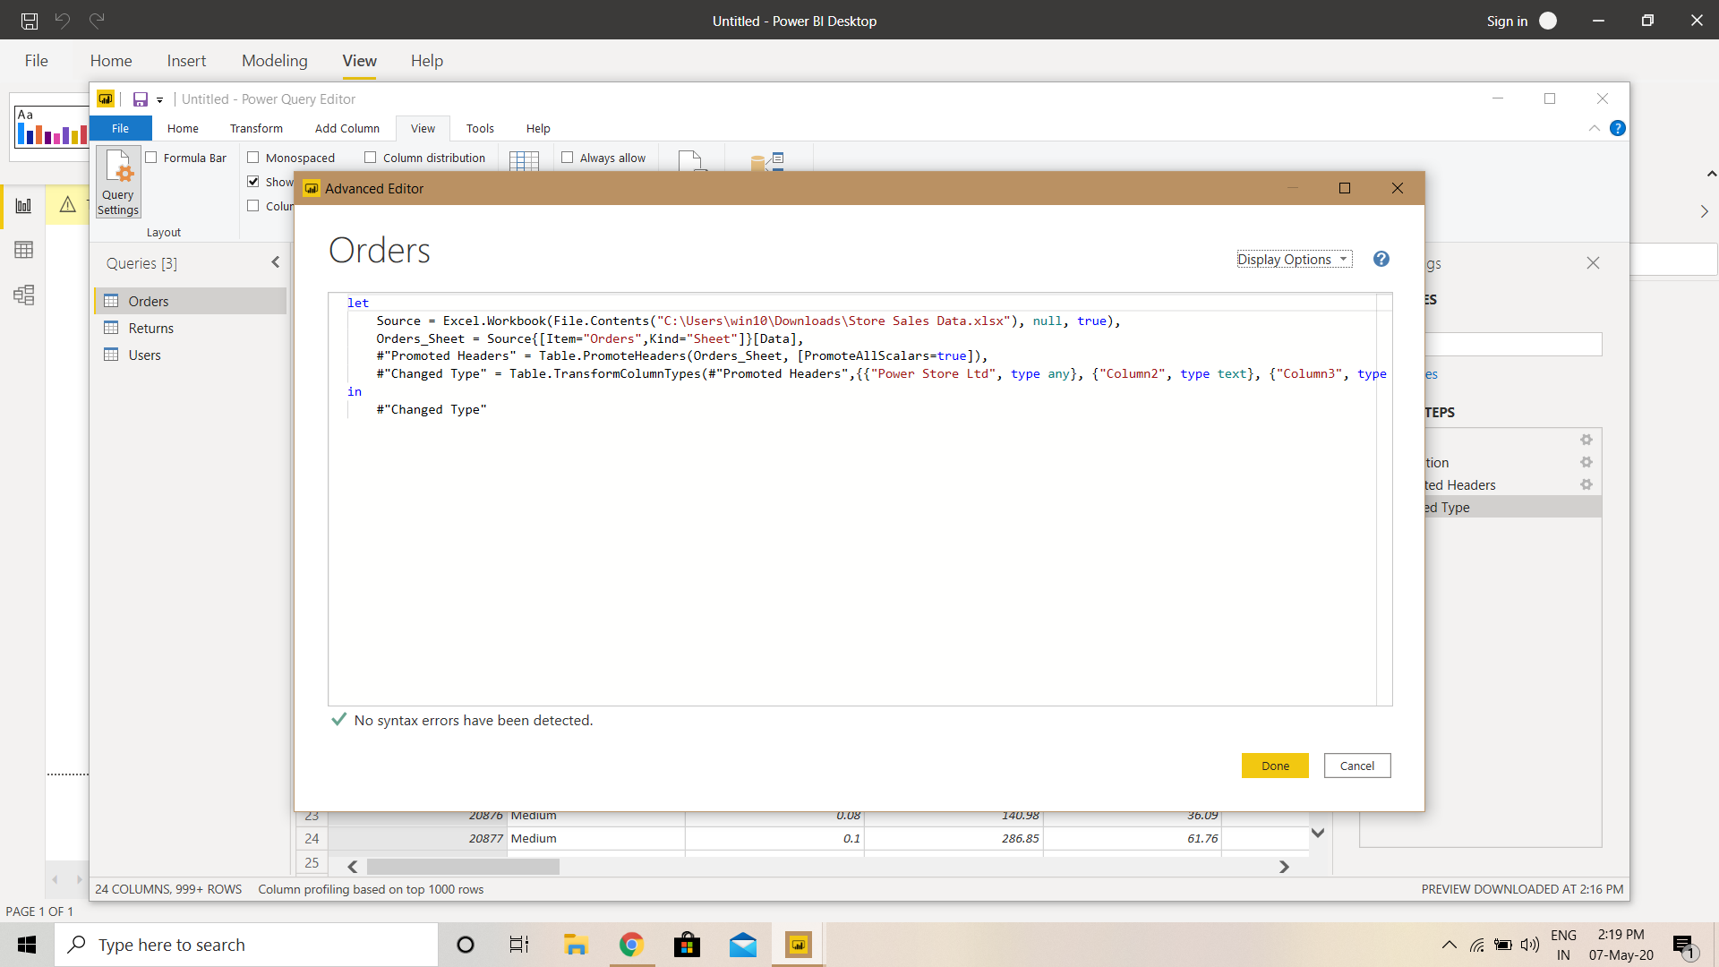

POWER BI Desktop is a free application that can be installed on desktop

POWER BI Pro is an individual user license that lets users read and interact and you can share your dashboard with other users with licenses $10/user/month.

POWER BI Premium has the capability to publish reports broadly across the enterprise. Greater share and performance. $4995/month.